1.

#*include* <iostream>

#*include* <conio.h>

#*include* <iomanip>

using namespace std;

*main*()

{

     char degree = 248;

     float firstTemp = -5.4, secondTemp = 124.67, thirdTemp = 305.15;// *Celius, Farenheight, Kelvin*

     float firstFarenheightConversion, firstKelvinConversion, firstRankineConversion;

     firstFarenheightConversion = ((1.8) \* firstTemp) + 32;

     firstKelvinConversion = (firstTemp) + 273.15;

     firstRankineConversion = firstFarenheightConversion + 459.67;

     cout *<<* *setprecision*(2) *<<* *fixed* *<<* "First Constant Value = " *<<* firstTemp *<<* degree *<<* "C\n"

*<<* degree *<<* "F = " *<<* firstFarenheightConversion *<<* degree *<<* "F\n"

*<<* degree *<<* "K = " *<<* firstKelvinConversion *<<* degree *<<* "K\n"

*<<* degree *<<* "R = " *<<* firstRankineConversion *<<* degree *<<* "R\n";

     float secondFarenheightConversion, secondKelvinConversion, secondRankineConversion;

     secondFarenheightConversion = 5 \* (secondTemp - 32) / 9;

     secondKelvinConversion = secondFarenheightConversion + 273.15;

     secondRankineConversion = secondTemp + 459.67;

     cout *<<* "\nSecond Constant Value = " *<<* secondTemp *<<* degree *<<* "F\n"

*<<* degree *<<* "F = " *<<* secondFarenheightConversion *<<* degree *<<* "C\n"

*<<* degree *<<* "K = " *<<* secondKelvinConversion *<<* degree *<<* "K\n"

*<<* degree *<<* "R = " *<<* secondRankineConversion *<<* degree *<<* "R\n";

     float thirdFarenheightConversion, thirdCelciusConversion, thirdKelvinConversion, thirdRankineConversion;

     thirdFarenheightConversion = (thirdTemp - 491.67) \* 5 / 9;

     thirdCelciusConversion = thirdFarenheightConversion;

     thirdKelvinConversion = ((1.8) \* thirdFarenheightConversion) + 32;

     thirdRankineConversion = thirdTemp \* 0.5555555556;

     cout *<<* "\nThird Constant Value = " *<<* thirdTemp *<<* degree *<<* "R\n"

*<<* degree *<<* "C = " *<<* thirdFarenheightConversion *<<* degree *<<* "C\n"

*<<* degree *<<* "F = " *<<* thirdKelvinConversion *<<* degree *<<* "F\n"

*<<* degree *<<* "R = " *<<* thirdRankineConversion *<<* degree *<<* "R\n";

*getch*();

}

Output:

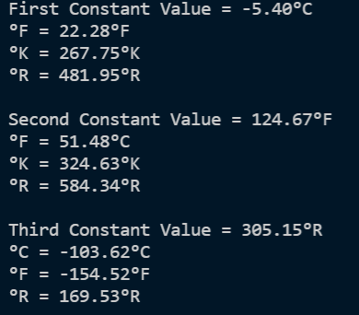

In this program, we are tasked to convert temperature values to different units of temperature. To do so, we are given the equations to certain conversions such as:

$$°F=\frac{9}{5}°C+32$$

$$°K=°C+273.15$$

$$°R=°F+459.67$$

However, we cannot use these equations for all the conversions that we are going to do. In this case, we are going to derive these 3 equations to find the other units.

$$°C=\frac{5\left(°F-32\right)}{9}$$

$$°K=\frac{5\left(°F-32\right)}{9}+273.15$$

$$°C=°K-273.15$$

$$°F=\frac{9\left(°K-273.15\right)}{5}+32$$

$$°C=\frac{5\left(°R-491.67\right)}{9}$$

$$°F=°R-459.67$$

$$°K=\frac{5°R}{9}$$

We will use these derived equations in finding the missing conversions in the supplementary problem.

One more feature that I used in the code is using <iomanip>. I used iomanip to manipulate the output of the numbers in the terminal. In this case, I used setprecision(2) << fixed where it will only show 2 decimals, and adding fixed to it will only fix it to 2 decimals no matter how many decimals are there.

2.

#*include* <iostream>

#*include* <conio.h>

#*include* <cmath>

using namespace std;

*main*()

{

    cout *<<* "N\t2^n\n"

*<<* "0\t" *<<* *pow*(2, 0) *<<* "\n"

*<<* "1\t" *<<* *pow*(2, 1) *<<* "\n"

*<<* "2\t" *<<* *pow*(2, 2) *<<* "\n"

*<<* "3\t" *<<* *pow*(2, 3) *<<* "\n"

*<<* "4\t" *<<* *pow*(2, 4) *<<* "\n"

*<<* "5\t" *<<* *pow*(2, 5) *<<* "\n"

*<<* "6\t" *<<* *pow*(2, 6) *<<* "\n"

*<<* "7\t" *<<* *pow*(2, 7) *<<* "\n"

*<<* "8\t" *<<* *pow*(2, 8) *<<* "\n";

*getch*();

}

Output:

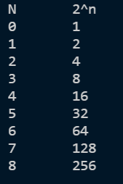

In the second supplementary problem, I used the library cmath to utilize the pow function. The pow function is used to indicate exponents in numbers. The format is as follows: pow(base, exponent), where the base is the base number and the exponent is the value raised to the base number. For example, we can write $2^{4}$ as pow(2, 4) as we write it in C++ programs.

#*include* <iostream>

#*include* <conio.h>

#*include* <cmath>

using namespace std;

*main*()

{

    float a, T, m, g;// *a = initial acceleration T - thrust in Newton m - mass in kg g - acceleration caused by gravity in m/s^2*

    T = 6e6;

    g = 9.81;

    m = 5e4;

    a = (T - (m \* g)) / m;

    cout *<<* "The initial acceleration, a, of a rocket fired from earth , with an initial thrust, T, is given by this formula:\n a = (T - mg) / m\n where:\n a = initial acceleration \n T = thrust in Newton\n m = mass in kg\n g = acceleration caused by gravity in m/s^2"

*<<* "\nWrite and run a program that will determine the initial acceleration of a rocket having a mass of 5X10^4 kg and an initial thrust of 6X10^5 Newtons. The Value of g is 9.81m/s^2.\n\n";

    cout *<<* "The initial acceleration is " *<<* a *<<* "m/s^2.";

*getch*();

}

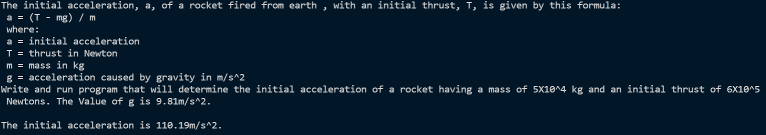

In the last supplementary problem, we used scientific notations in indicating our values. We write scientific notations as $aeb$, where a is the base number, e is denoted by $×10$, and b is the exponent. For example, we can write $6×{10}^{4}$ as *6e4.* The formula provided is used in finding the initial acceleration.